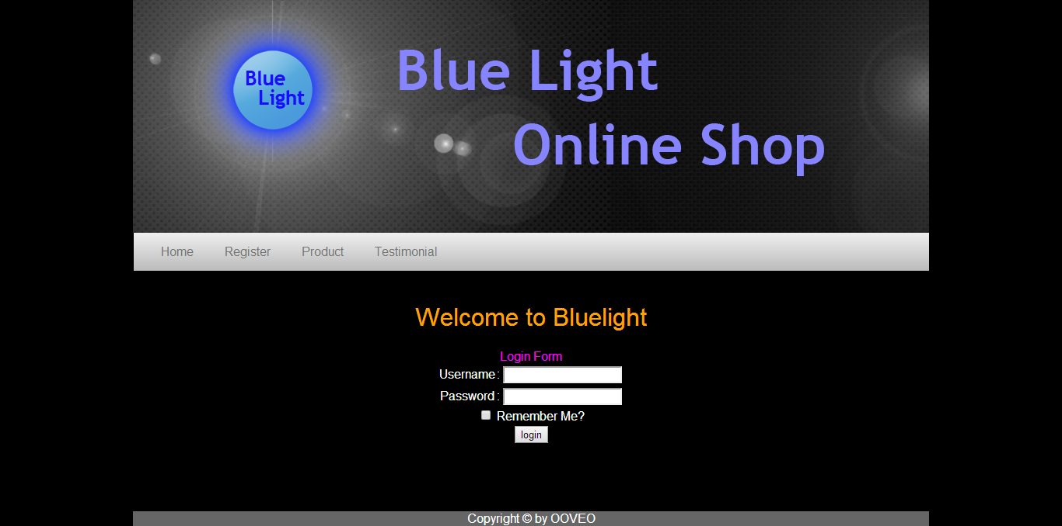**Blue Light Online Shop**

1. Home (guest)

Login dengan username dan password dengan tepat.

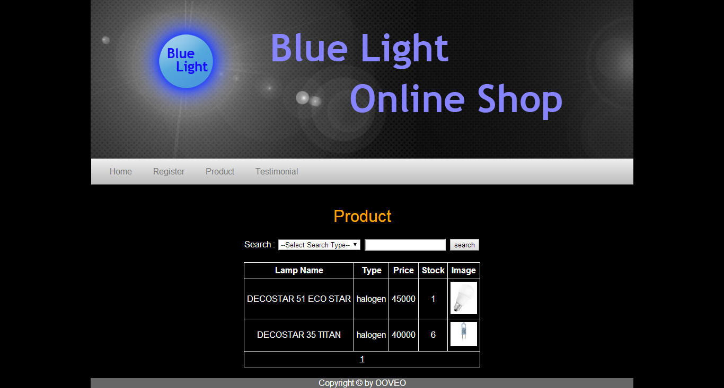

1. Product (guest)

Memperlihatkan jenis-jenis lampu yang dijual.

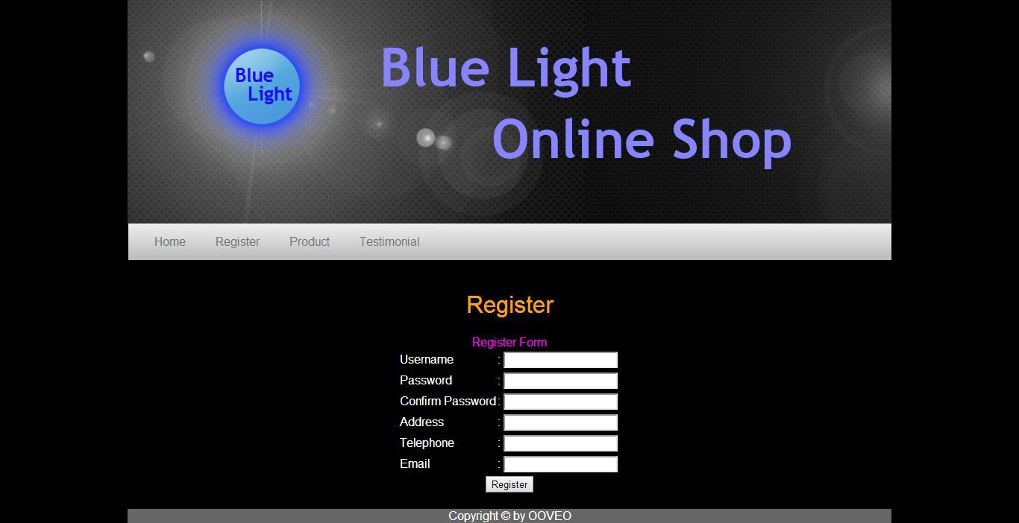

1. Register

Mendaftarkan diri untuk menjadi member Blue Light Online Shop.

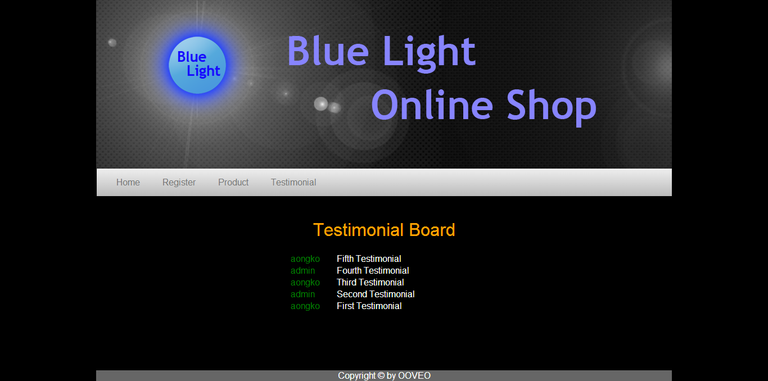

1. Testimonial (guest)

Menampilkan kepuasan member terhadap pembelian lampu melalui Blue Light Online Shop.

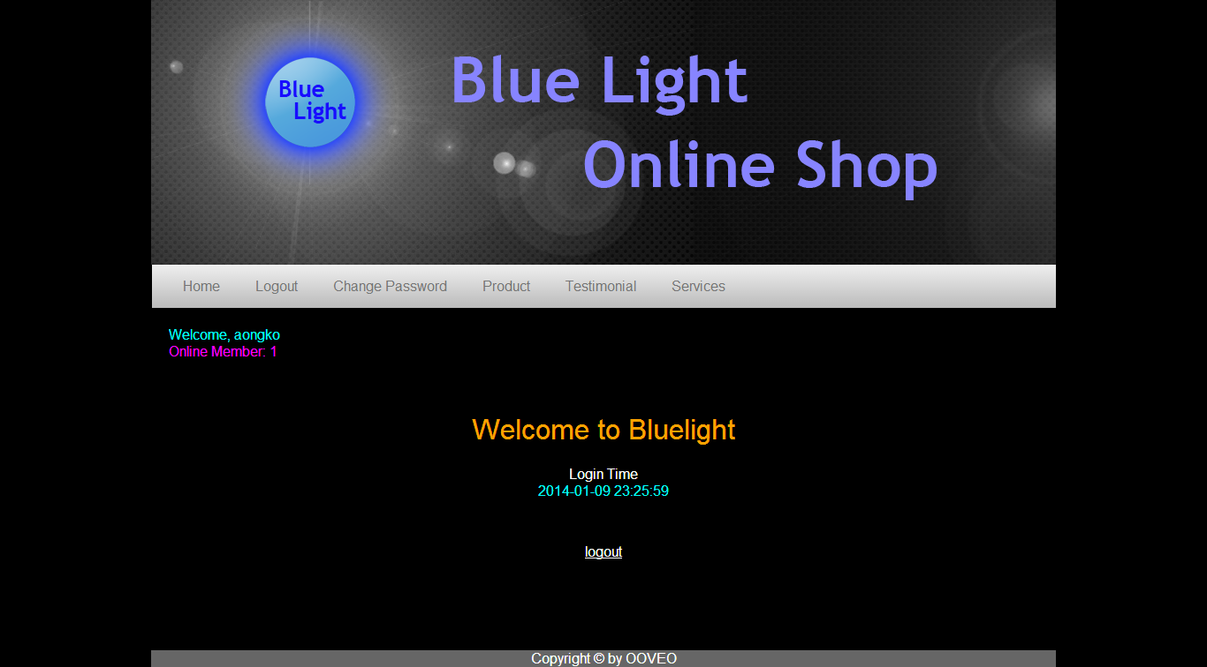

1. Home (user & admin)

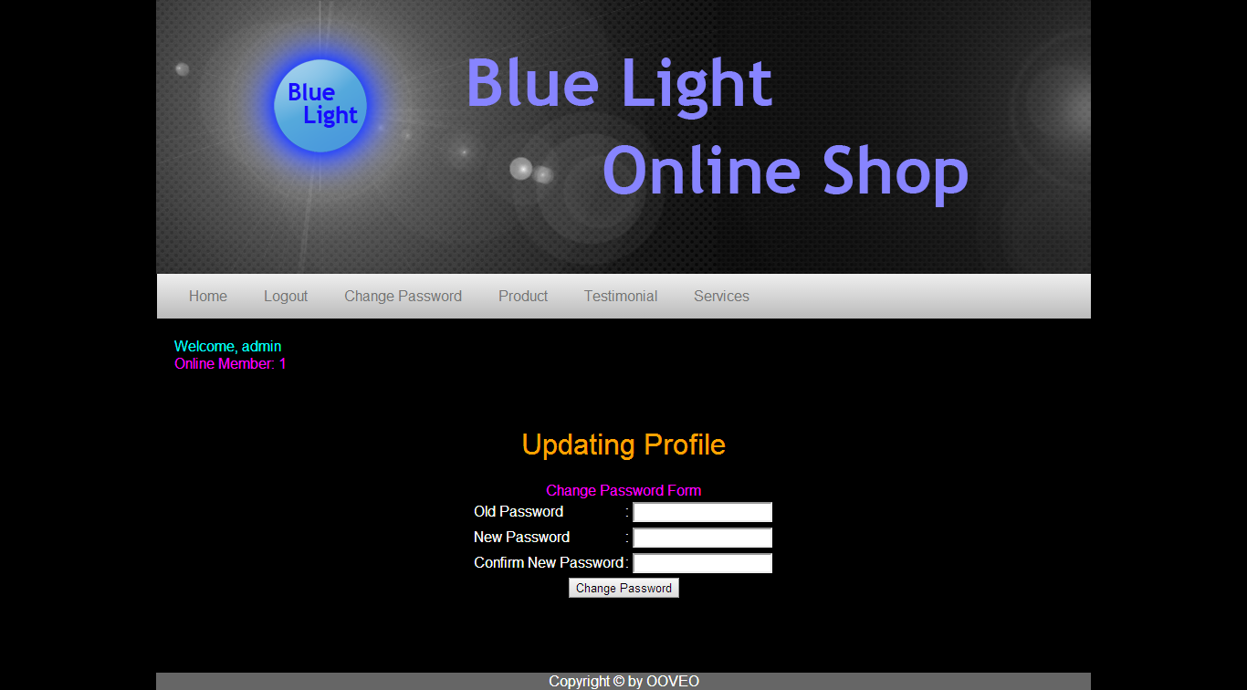

1. Change password (user & admin)

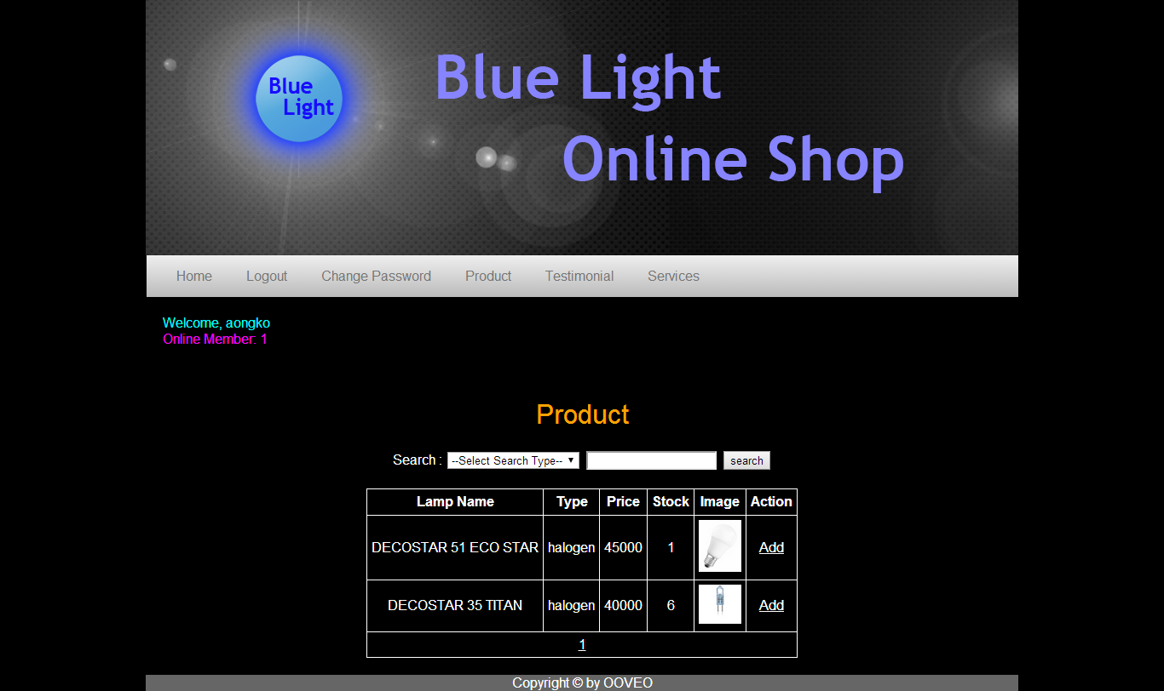

1. Product (user non-admin)

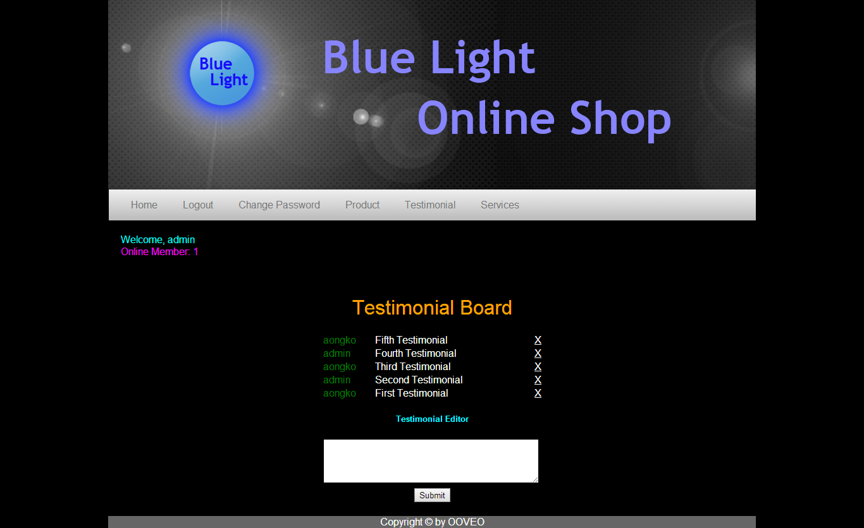

1. Testimonial (user & admin)

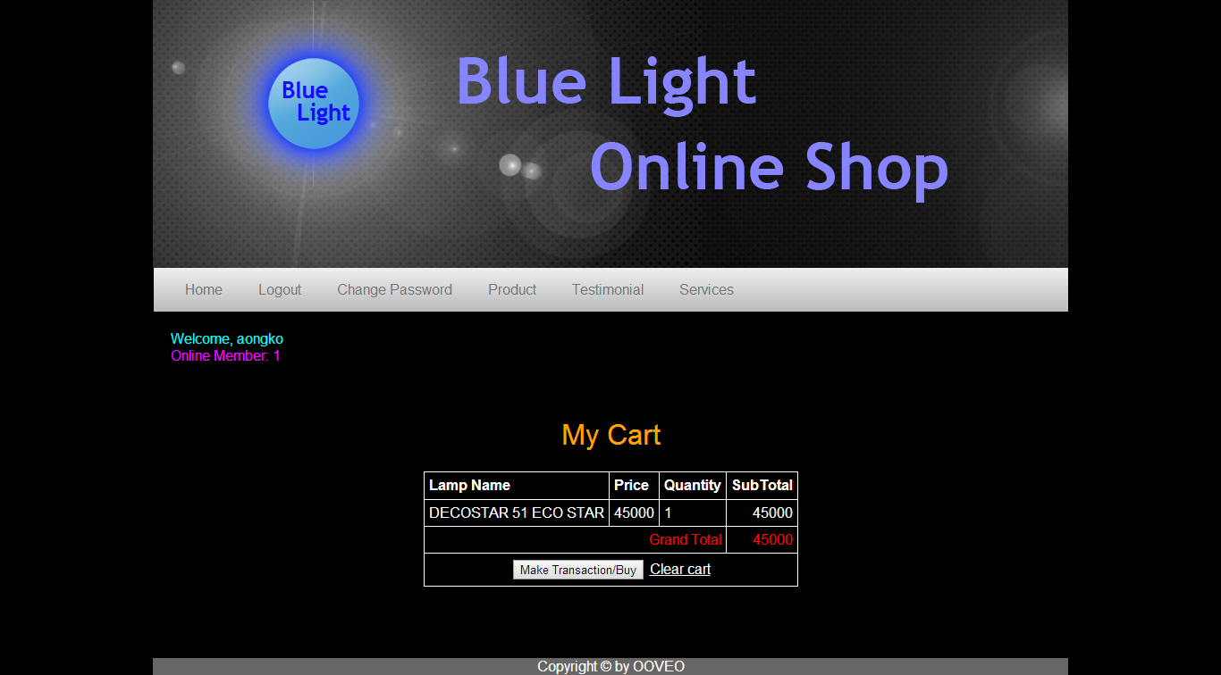

1. My cart (user)

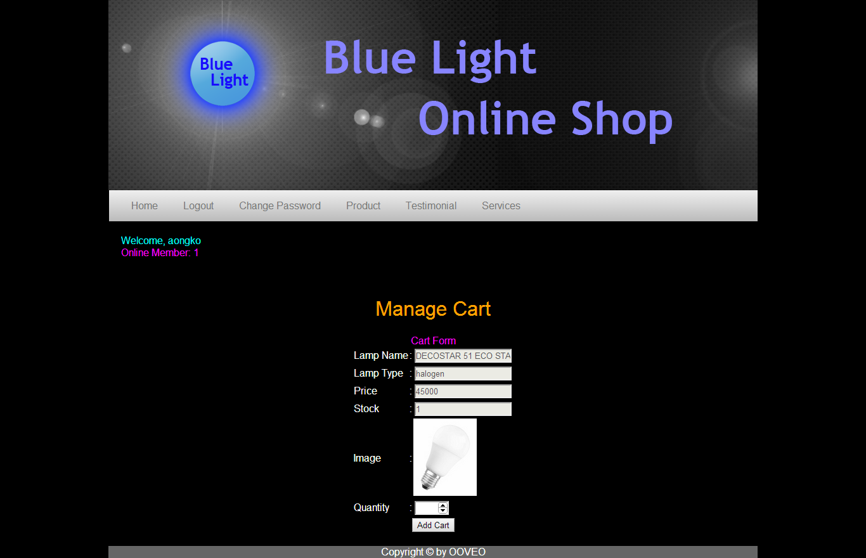

1. Manage cart (user)

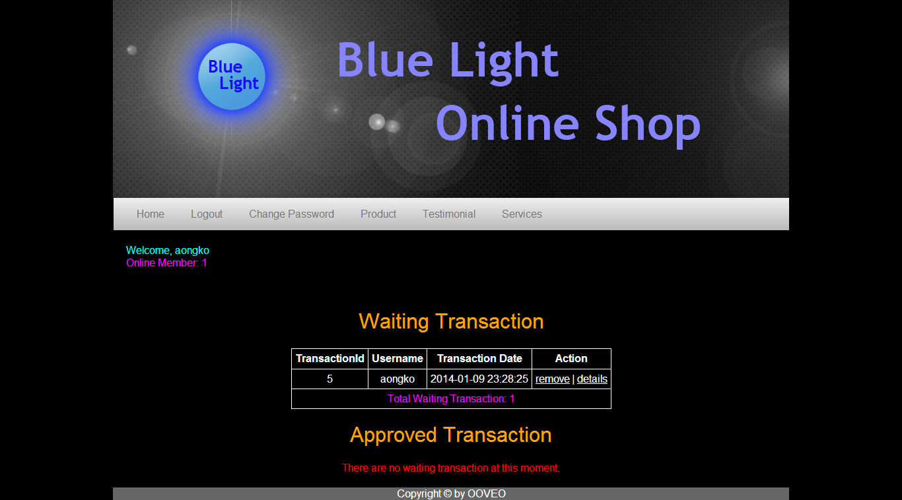

1. Transaction history – part 1 (user)

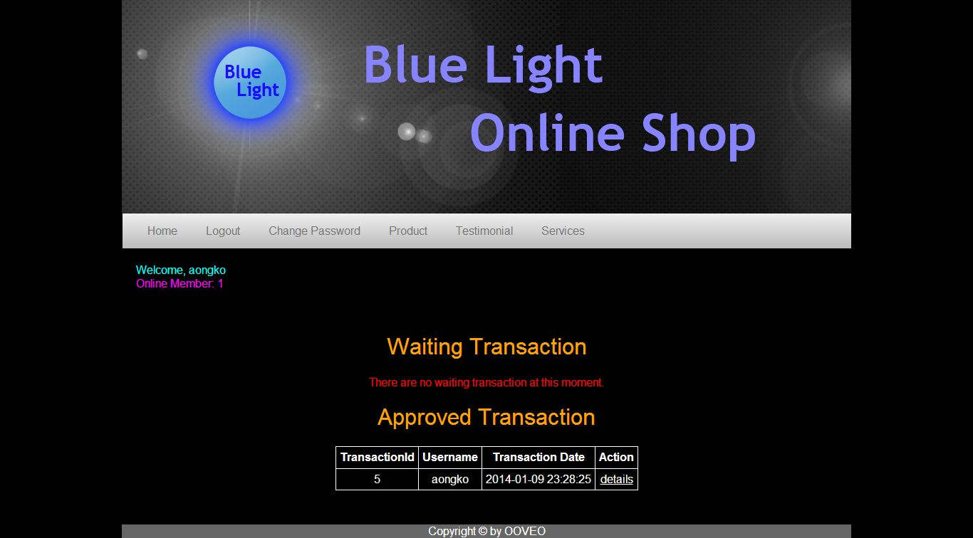

1. Transaction history – part 2 (user)

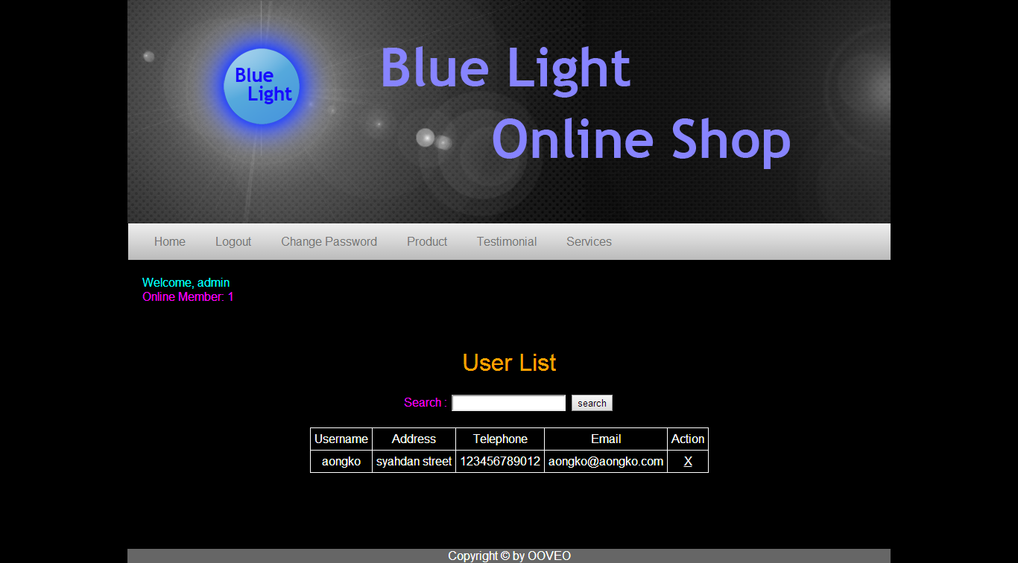

1. User list (admin)

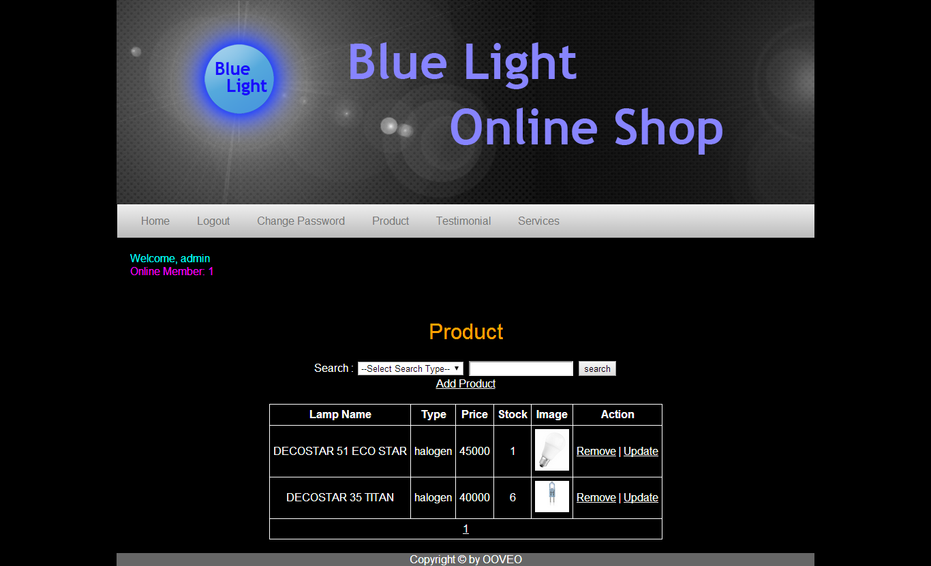

1. Product (admin)

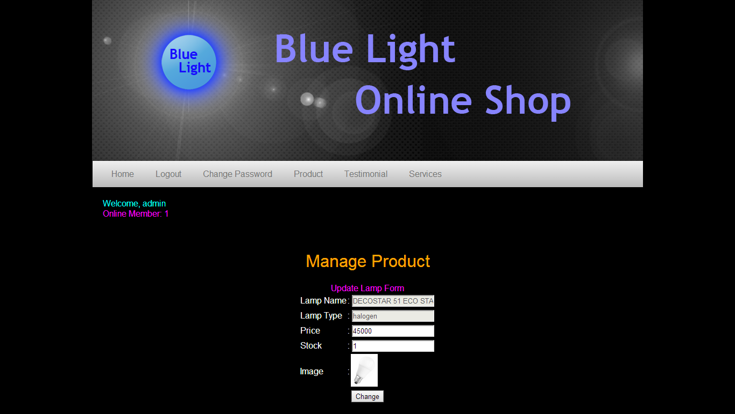

1. Update product (admin)

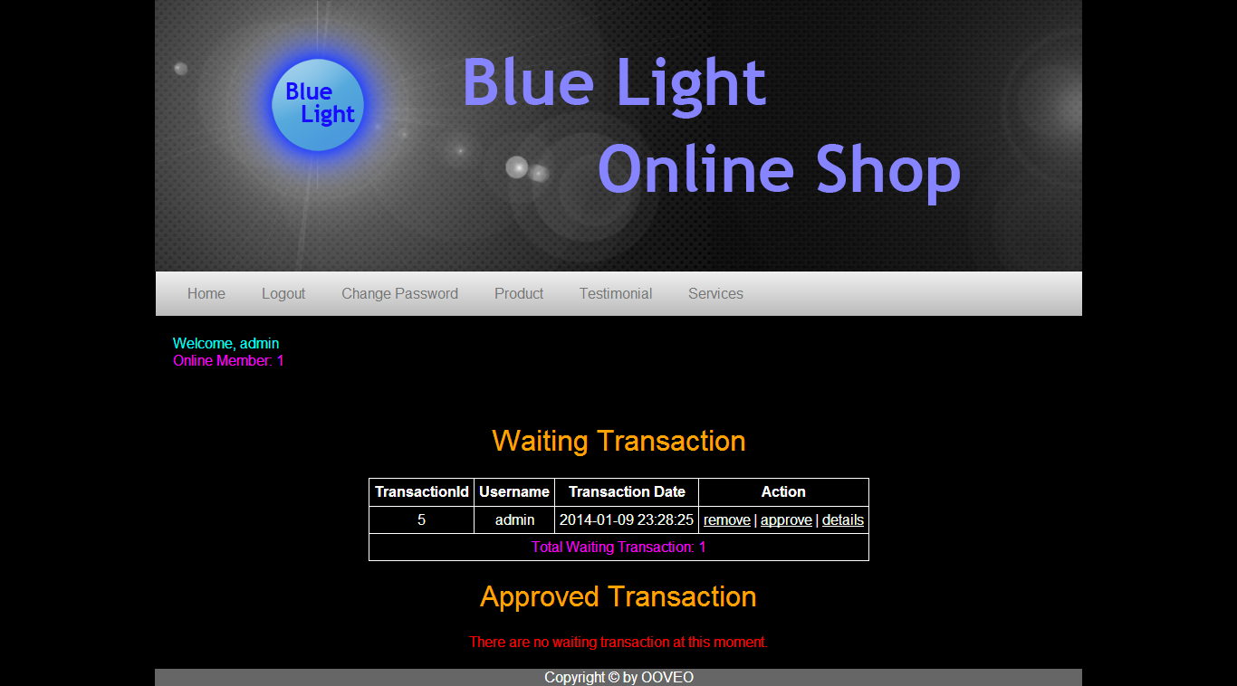

1. Transaction history – part 1 (admin)

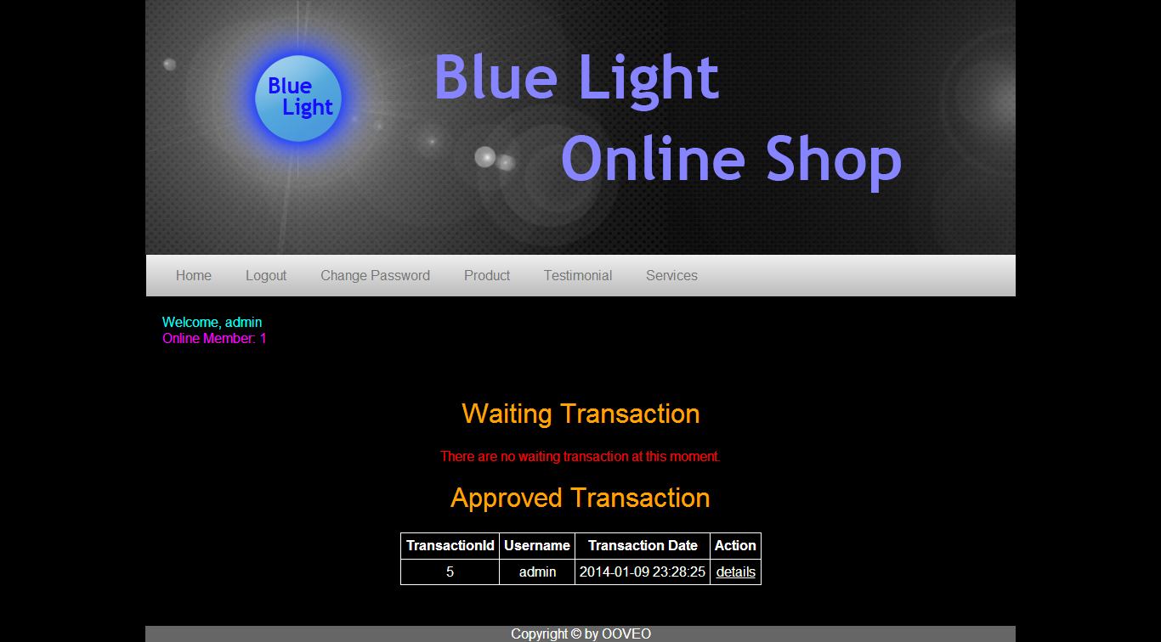

1. Transaction history – part 2 (admin)

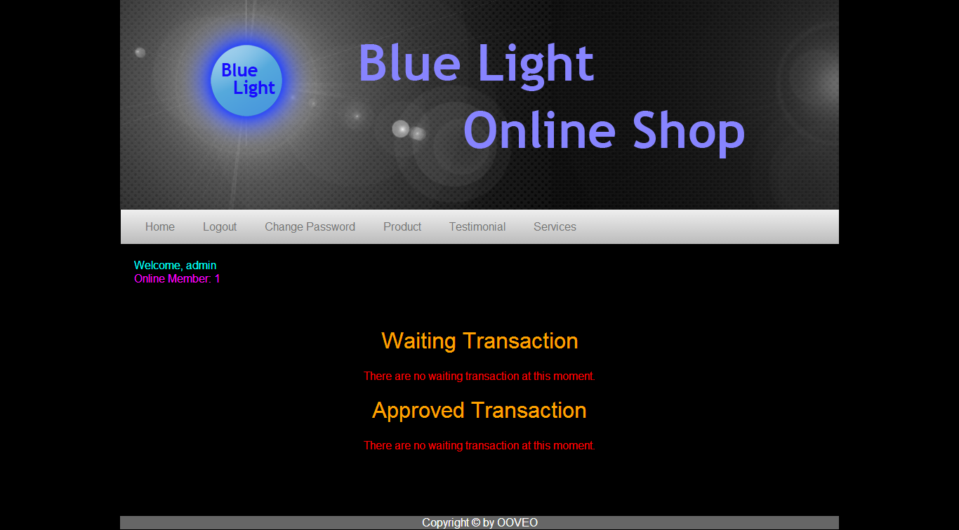

1. Transaction history – empty (admin)

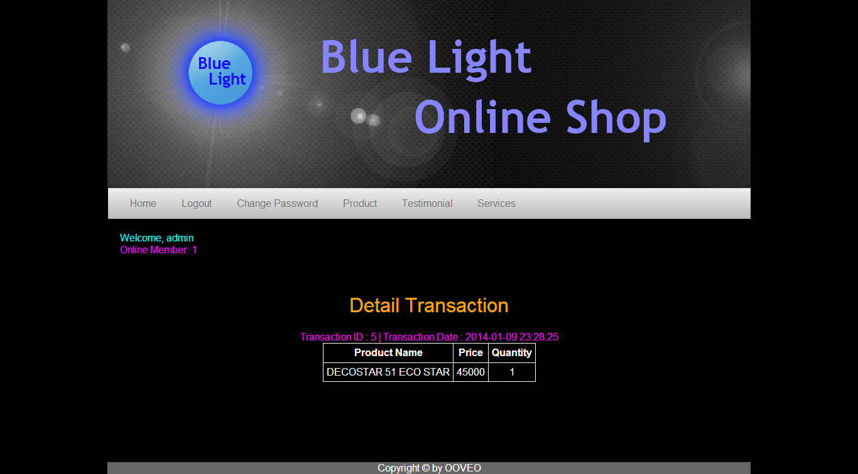

1. Detail transaction (admin)

Sumber:

<http://sixrevisions.com/tutorials/photoshop-tutorials/how-to-create-a-dark-and-sleek-blog-design-in-photoshop/>

<http://www.ecat.lighting.philips.com/l/lamps/halogen-lamps/20951/cat/>

<http://www.osram.com/osram_com/products/led-technology/lamps/index.jsp>